EXERCISE 1 - #pragma omp barrier

Files : exercise01.c
Compile / run
gcc -fopenmp exercise01.c -o exercise01
OMP_NUM_THREADS=4 ./exercise01

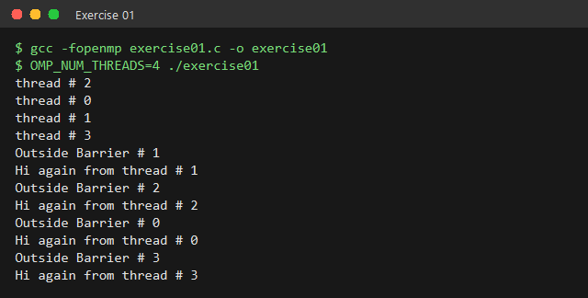
How omp barrier works in this program
* #pragma omp parallel creates a team of 4 threads; each prints
"thread # n".
* #pragma omp barrier is a synchronisation point. No thread may pass the
barrier until EVERY thread in the team has reached it.
* Because of this, all four "thread # n" lines are printed BEFORE any
"Outside Barrier" / "Hi again" line - the two groups never mix.
* Inside each group the order is still random, since the threads run
independently once they are released from the barrier.

